**Student User Manual**

Click the upper right corner to sign up/log in

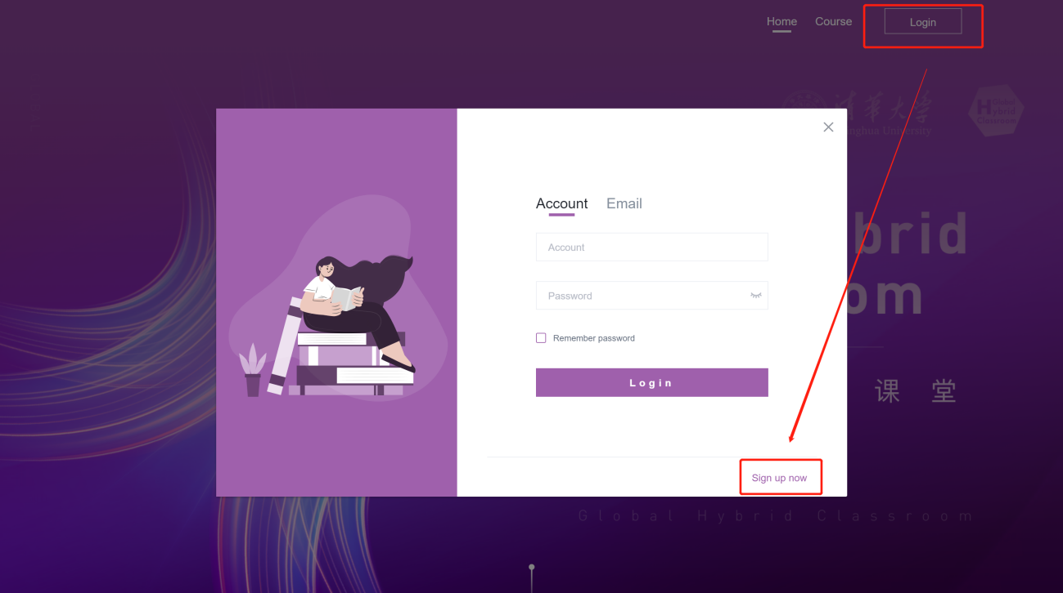c

**3.1 Sign up**

1. Fill out the information

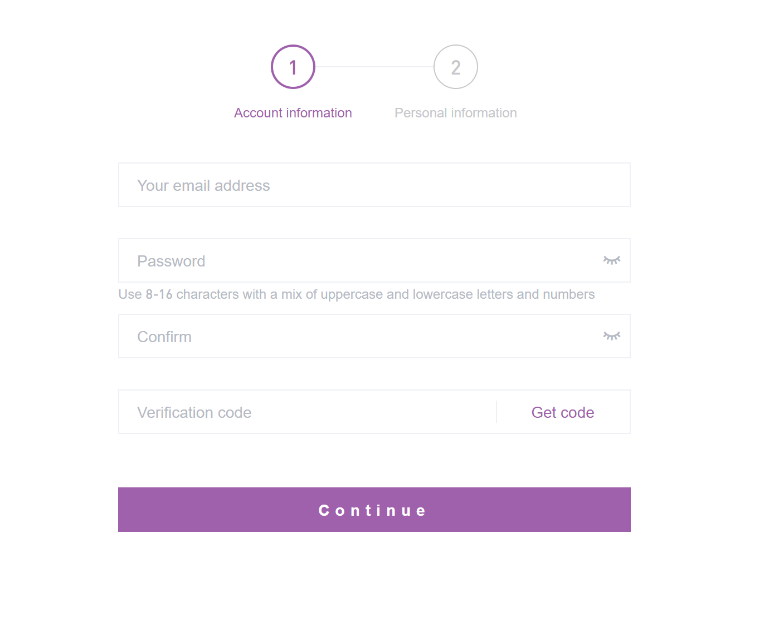

2. Enter the verification code sent via email.

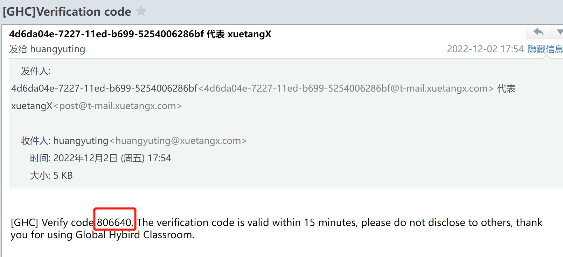

3. Fill in personal information, including your university

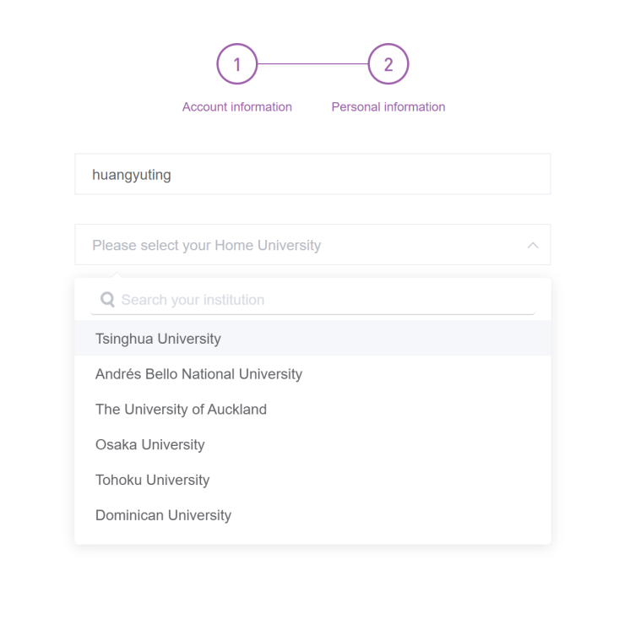

4. Registration completed

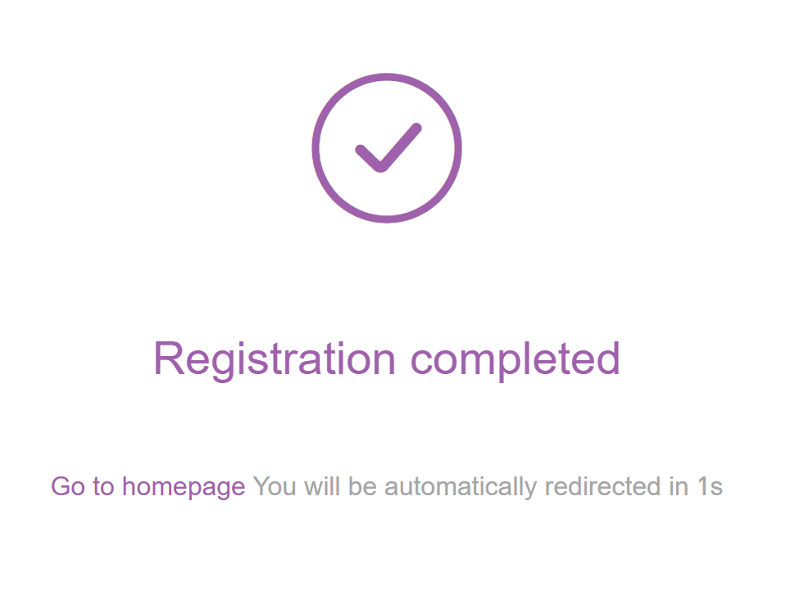

**3.2 Log in**

Log in using your account and password or an email verification code.

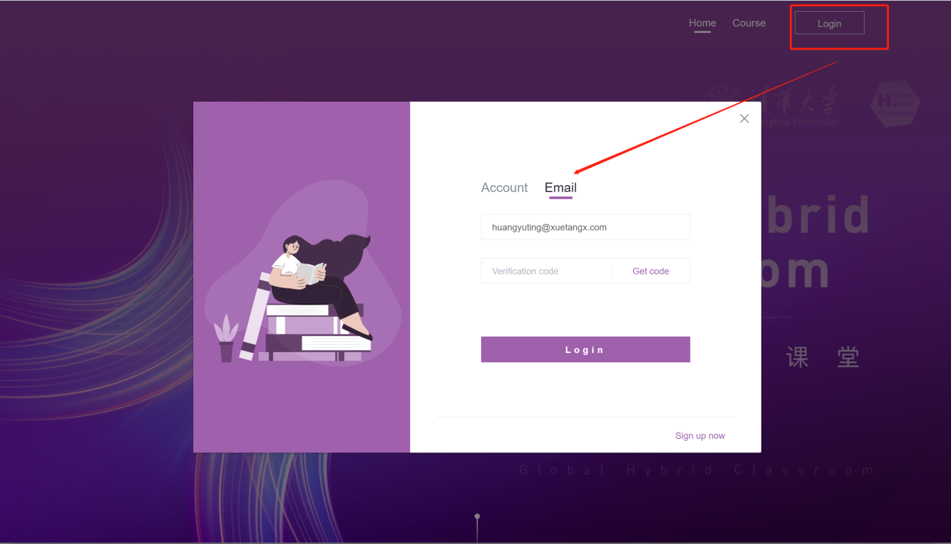

**3.3 Register for courses**

1. View the course page and university information, and click to view all courses offered.



2. Click to view the course details and descriptions



3. Click to register for the course, fill out the registration form (if not logged in, you will be reminded to log in, after which you can register for courses).



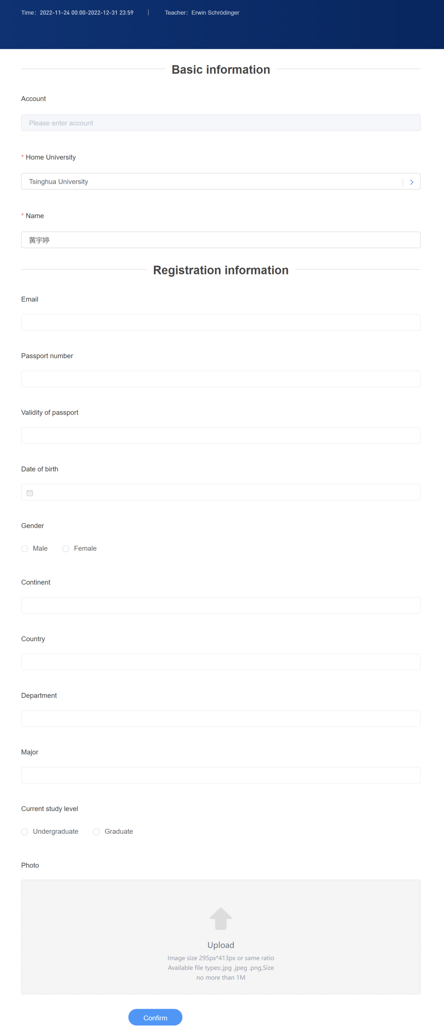

**3.4 Check Application Status**

After applying for registration, you can view your application status in the system.



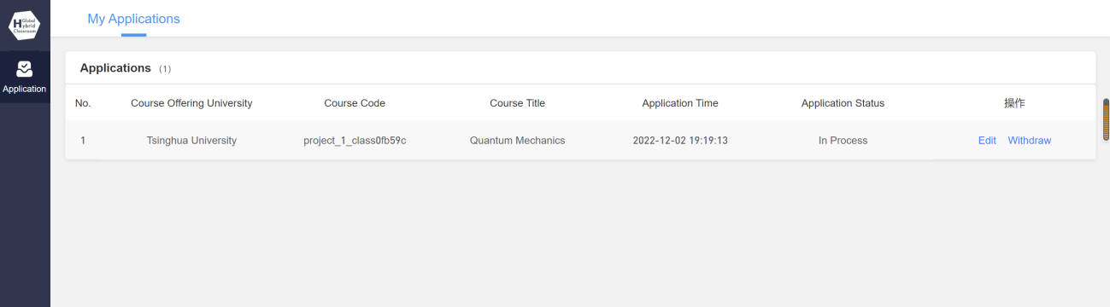

Application Status: Status of application review

Edit: You can edit and submit your application before it is reviewed

Withdraw: After withdrawing, you can only reapply and cannot resubmit the previous application